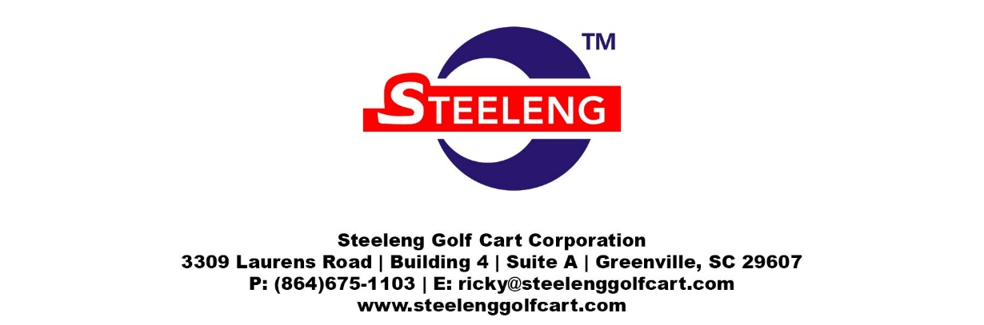

Valued Customer,

Thank you for choosing Steeleng Golf Cart Accessories for your golf cart needs. We apologize for the issues you are having with your purchase. We strive to offer the absolute best quality at the absolute best price. To best serve you, we do need a little information to help process your return and/or exchange faster. Please complete the information below and include this entire form with your return.

Please complete this RMA Form and email it back to ryan.sloan@steelenggolfcart.com
A RMA # will then be assigned and acknowledged to you authorizing merchandise to be returned exchange or refund. Please be sure to include a copy of this RMA Form with your return to ensure the return can be processed without delays.
RMA # Return Materials Authorization
Ship to Name and Address | Bill to Name and Address (if different)
 | Click here to enter text.

Customer Contact | Order Details
Company: Click here to enter text. | Item Being Returned: Click here to enter text.
Name: Click here to enter text. | Description: Click here to enter text.
Address: Click here to enter text. | Original Invoice or Sales Record
Phone: Click here to enter text. | Returned For:  EXCHANGE
Email: Click here to enter text. | Purchased by:  DEALER
Return Tracking No: Click here to enter text. | Replacement Tracking No: Click here to enter text.
RMA # Click here to enter text.

Reason for Return:
Description of Problem:

For Internal Use Only:
Received By: | Date Received:
Inspected By: | Inspection Date:
Condition of Return: | Damaged or Missing Parts:
Eligible to be returned to Inventory:  Yes No | RMA # ____________________________

_ _ _ _ _ _ _ _ _ _ _ _ _ _ _ _ _ _ _ _ _ _ _ _ _ _ _ _ _ _ _ _ _ _ _ _ _ _ _ _ _ _ _ _ _ _ _ _ _ _ _ _ _ _ _ _ _ _

Instructions for Warehouse:
RMA # Click here to enter text. | Authorized By: Click here to enter text.
Return to Inventory  Choose an item. | Other Instructions: Click here to enter text.

Please return all merchandise to:
Steeleng Golf Cart Corporation
3309 Laurens Rd
Building 4, Suite A
Greenville, SC 29607

**Steeleng Golf Cart Corporation reserves the right to charge a 15% restocking fee for all returned and/or exchanged items.

